**Dimension | Progress Report — July 2019**



**1. Technical Progress**

The development progress of the Dimension project is progressing in an orderly manner. The main points of technical progress in July are as follows:

**Hybrid Consensus**

* The underlying code development of the DPOS+PBFT hybrid consensus is completed.
* HPoS-P consensus algorithm can reach 8000TPS on the test net.
* RBFT, based on the Hotstuff algorithm, has a definite development plan for Q3
* The construction of the converting consensus algorithm model of HPoS-P and HPoS-R is completed.

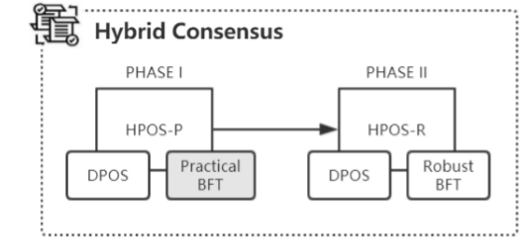

**Dynamic Node**

* The node registration proposal mechanism involved with the contract interface ports are completed.
* The joining, approving, and removing procedures of new-entry nodes are tested and approved.
* The scheduling mechanism of underlying code DN-Core:

A：The broadcast mechanism code has been completed and tested.

B：The buffering mechanism framework of the newly added node has been built.

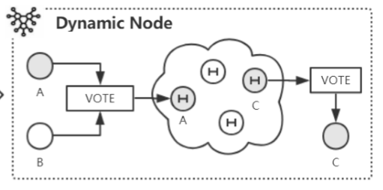

**ConsensusX**

* The coding of the consensus switching proposal process has been completed and is under test.
* Prefabricated mainstream consensus algorithm has been completed.
* The open consensus algorithm interface API (initial, load, etc.) is partially completed.

